COSC 4302: Introduction to Operating Systems
Assignment 2
Due: 10:00am, Sept. 20, 2024 (Friday)

Name: Francisco Barrera Cribas

LUID: L20414152

Date: 09/20/24

- Please refer to the following figure – Polling I/O Read operation
1.a What information does the status register include? (4 points)
The status register includes information such as the status or current state of the device controller, known as flags, which are then used by the CPU to manage communication with the device. Flags also serve to communicate whether the device is currently busy, whether it has encountered any errors, and whether there is any data available to read.

1.b Please use a while-loop to implement step 4 in Figure 5.7. (6 points)
while ((status & 0x01) == 0) {
status = read_status_register();
}
The loop works by continuing reading the status register until the least significant bit is set to 1, indicating that there is data available to read.

1.c How do you use the information in the status register to implement step 2? Please use a while loop to write down the pseudo-code. (5 points)
//read the status register to check the device’s current status
Status = read_status_register();

//while loop until the device is ready
//the loop will continue until the device_ready_bit is not set in the status register
While ((status & device_ready_bit) == 0 ) {
//read the status register again to check if the device is ready
Status = read_status_register();
}
// At this point, the device_ready_bit is set (status & device_ready_bit == 1),
// indicating that the device is ready to perform the requested operation.
// Now, we can proceed with sending commands or data to the device controller.

device_ready_bit is a constant that represents the bit in the status register that indicates whether the device is ready. The loop will continue to read the status register until the bit is set to 1, indicating that the device is ready to perform the requested operation. Once the loop has exited, we can proceed with sending the appropriate command or data to the device controller.

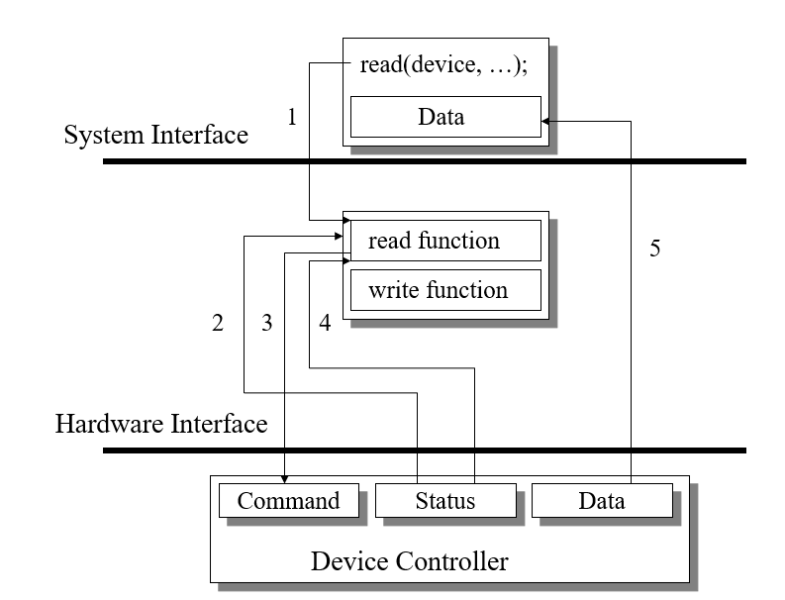

2. Textbook, P. 151 -> question 13. (question 13: Describe a new read function, xRead(), along with other functions that could enable one to write programs in a high-level language such that the application can continue processing after the xRead() call, but can block itself before using data in the process of being read) In this question, you just need to
- Explain the basic idea about how to implement xRead().
The basic idea behind the xRead() function is to allow a program to read data from a source, such as a file, without interrupting the program’s execution. The xRead() function should return immediately, regardless of whether or not any data is available to be read, which allows the program to continue processing. If you wish for the program do not use incomplete data, you can introduce mechanism such as flags or condition variables to check whether the data has been fully read before using it. A common approach is to use asynchronous I/O with a notification or callback mechanism, where xRead() starts the reading process, and the program can later check if the read is complete or block until the data is ready.

- Use a high-level language pseudocode (for example, C or C++ style pseudocode in the textbook) to develop an application, which can continue processing after the xRead() call, but can block itself before using data in the process of being read.

//define a global flag to indicate whether or not data is available to be read
bool dataReady = false;

//define a function to simulate reading data from a source
void xRead () {
//in a real program, this function would read data from a source
dataReady = true;
}

//define a function to process the data read by xRead()
void processData() {
//we'll just print a message to indicate that the data has been processed.
cout << “Data has been processed.” <<endl;
}
int main () {
// Call xRead() to begin reading data, but don't block the program's execution.
xRead();

// Check the global flag to see if data is available to be read.
if (!dataReady) {

// If data is not yet available, block the program's execution.
cout << "Waiting for data to be read." << endl;
while (!dataReady) {
// In a real program, this loop would typically block the program's execution
// until data is available to be read. For simplicity, we'll just use a busy loop.
}
}

// process the data read by xRead()
processData();

return 0;

}

(25 points)

3. Programming question
(60 points)

Please use thread to complete the following program: one process opens a file data.txt, then creates a thread my_thread. The job of the thread my_thread is to count how many lines exist in the file data.txt, and return the number of lines to the calling process. The process then prints this number to the screen.

Basically, you need to implement main_process.c and thread_function.c.

Basic structure of main_process.c:

int main ()
{
Open the file data.txt and obtain the file handler fh;

Create a thread my_thread using pthread_create; pass fh to my_thread;

Wait until my_thread terminates, using pthread_join;

Print out how many lines exist in data.txt.
}

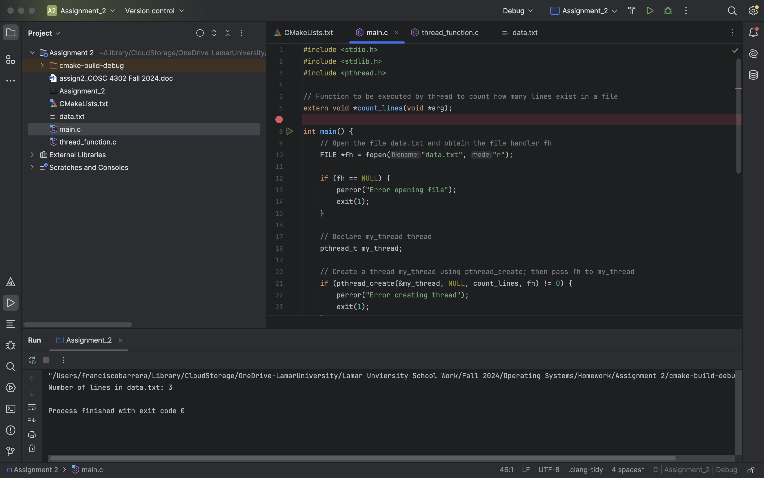

Basic structure of thread_function.c:

void *count_lines(void *arg)
{
Obtain fh from arg;

Count how many lines num_lines exist in fh;

Close fh;

Return num_lines
}
For information about pthread_create and pthread_join:

man pthread_create
man pthread_join

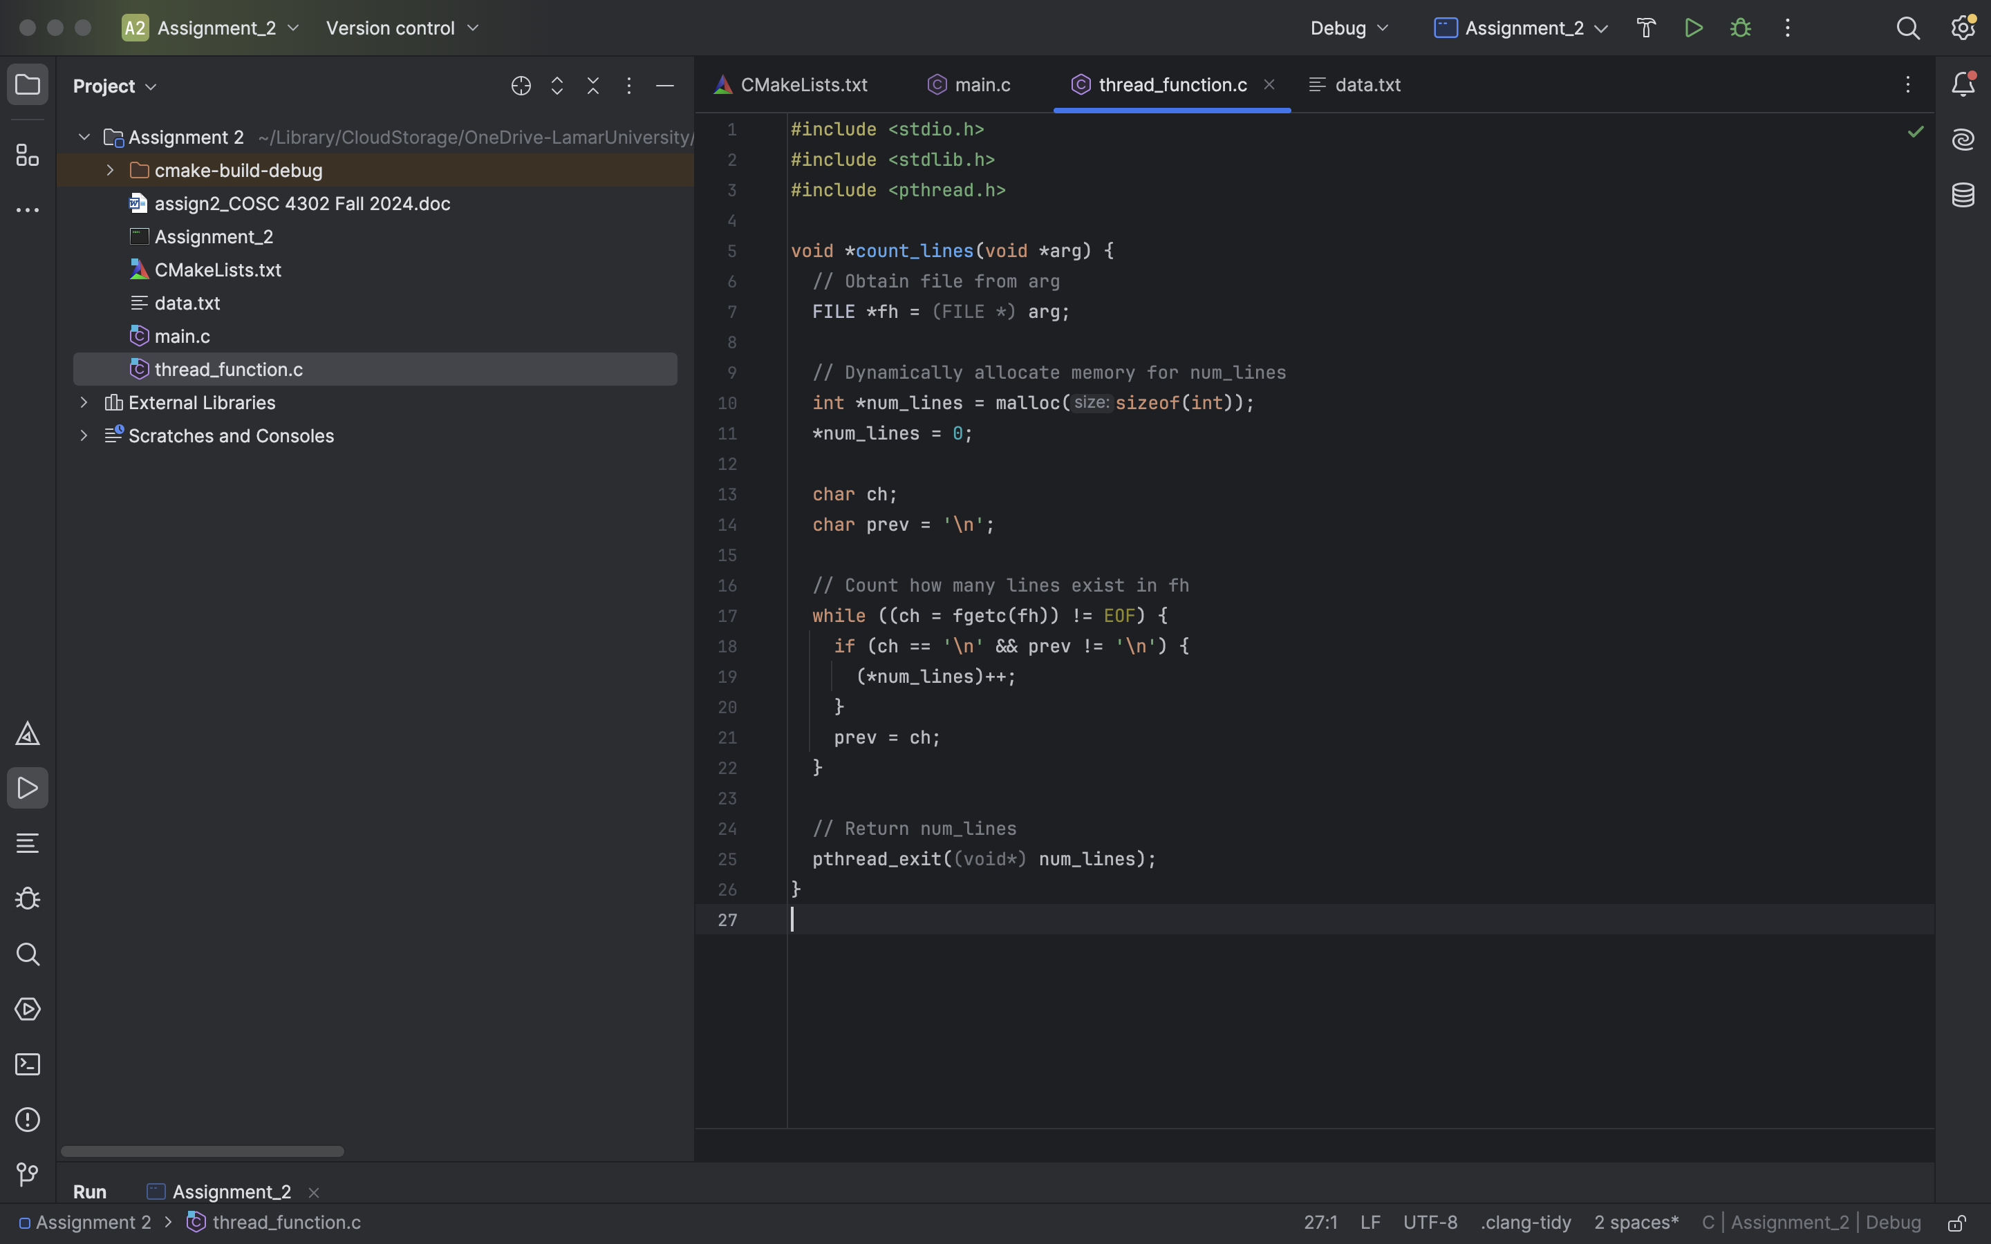

How to compile and link your program:

gcc -o my_example main_process.c thread_function.c -lpthread

You can create a simple data.txt to test your program.

For more examples, please refer to Chapter 12 of the following textbook:

Unix System Programming, K.A. Robbins and S. Robbins, Prentice Hall, ISBN: 0-13-042411-0, 2003

How to Turn In:

Softcopy: Please use BlackBoard to turn in your homework solutions. For programming questions, please do NOT use MS WORD. Please send .c or .cpp files.

Class Policy:

Some programming questions are used in previous semesters. Please do NOT borrow solutions from those students who have taken this class before. We keep a database of all previous solutions.

Programming solutions will be checked carefully for plagiarism. Students who are caught copying directly will receive 0 for this assignment.

Programming solutions will be checked carefully for plagiarism. Students who are caught copying directly will receive 0 for this assignment.
.

